**ESTIMATION OF BUSINESS EXPENSES**

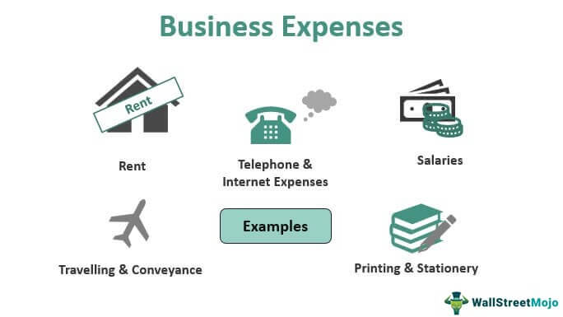

**1. Introduction**

* An expense is a cost that businesses incur in running their operations.
* Expenses include wages, salaries, maintenance, rent and depreciation.
* Expenses are deducted from revenue to arrive at profits.

Purpose

* It is used to solve the problem of business expenses.
* To show a company’s net profit or loss and taxable income.

**2. Problem definition & design thinking**

**Empathy map**

* Empathy map is a tool used in design think to build an emotional representation of a user or the customer.

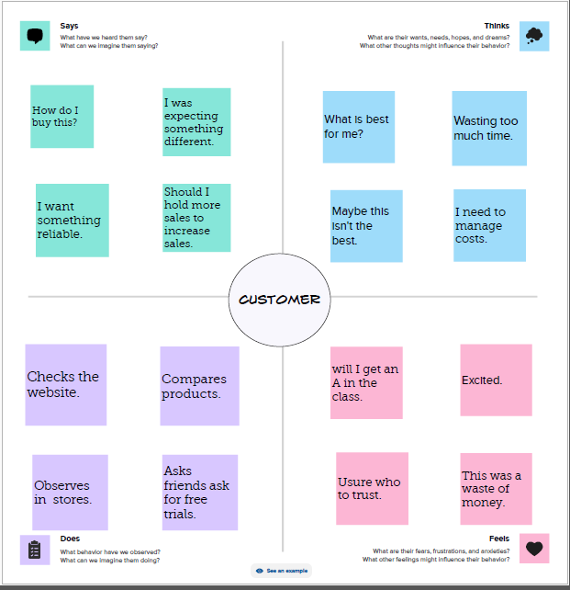

**Ideation & brainstorming map**

* **A** mind map is a visualization technique and brainstorming tool which allows you to explore a central idea, and all of its related topics, in a non-linear way.

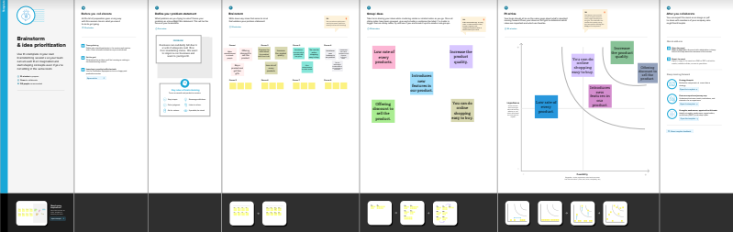

**3. Result**

* **collect a data set**
* We are collected the dataset in online and download the data set.
* **connect the data set with tableau**
* Installed the tableau desktop.
* Connect the data set with tableau using the reference video.
* **Dashboard**
* Combine two or more sheets to create a dashboard.

**DASHBOARD 1**

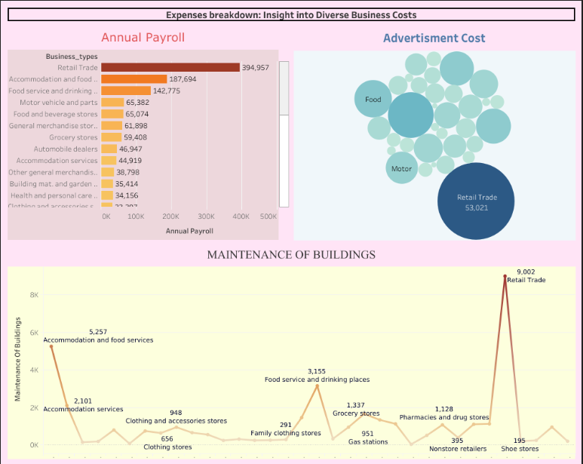

<https://public.tableau.com/app/profile/p.rithikasri/viz/Dashboard-1_16964099733850/Dashboard1?publish=yes>

DASHBOARD 2

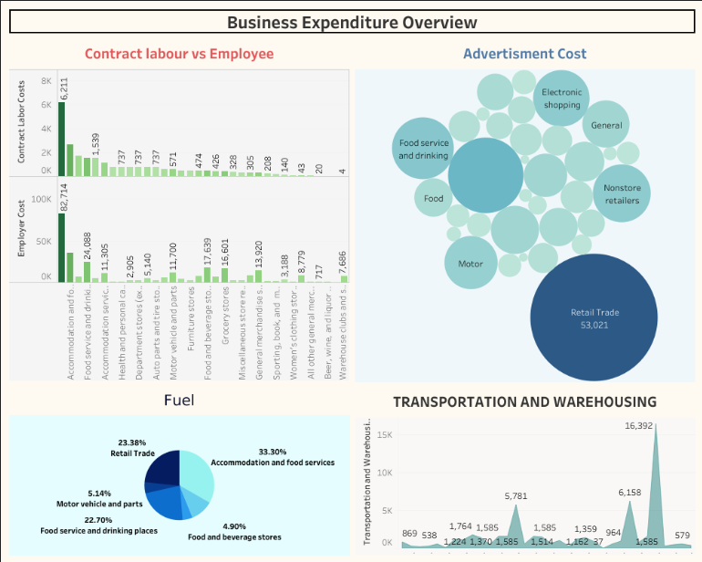

<https://public.tableau.com/app/profile/p.rithikasri/viz/Dashboard-2_16964103819570/Dashboard2?publish=yes>

DASHBOARD 3

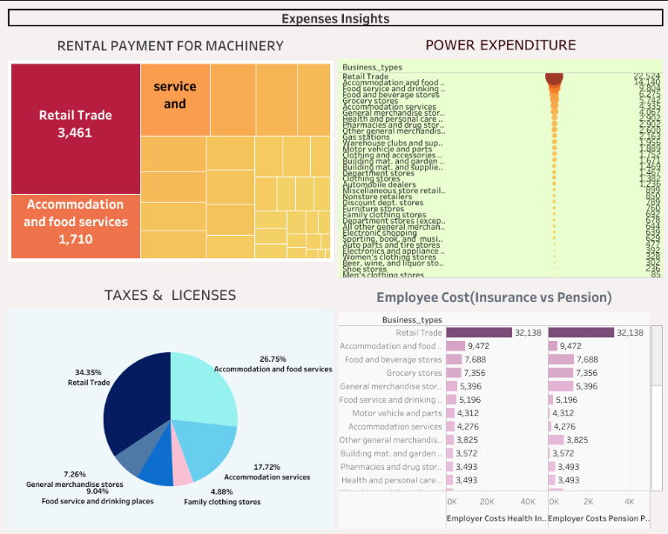

<https://public.tableau.com/views/Dashboard-3_16964107948900/Dashboard3?:language=en-US&publish=yes&:display_count=n&:origin=viz_share_link>

* Our graphical representations are displayed above.
* **Story**
* **A** Story is a sheet, so the method is used to create, name, and manage worksheets and dashboards also apply to stories.
* At the same time, a story is also a collection of sheets, arranged in a sequence.
* Each individual sheet in a story is called a story point.

**STORY 1**

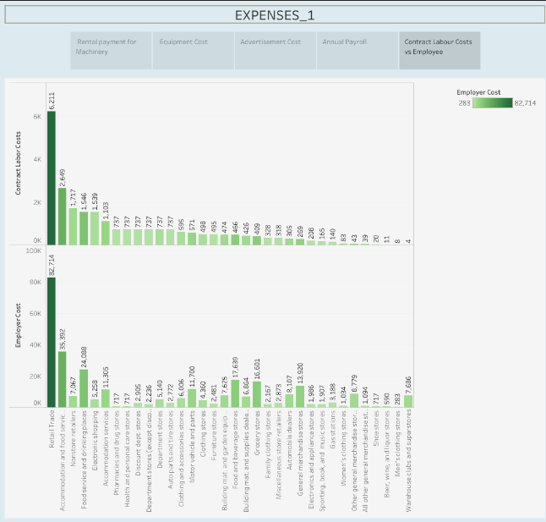

<https://public.tableau.com/app/profile/p.rithikasri/viz/STORY-1_16969242550530/Story1?publish=yes>

**STORY 2**

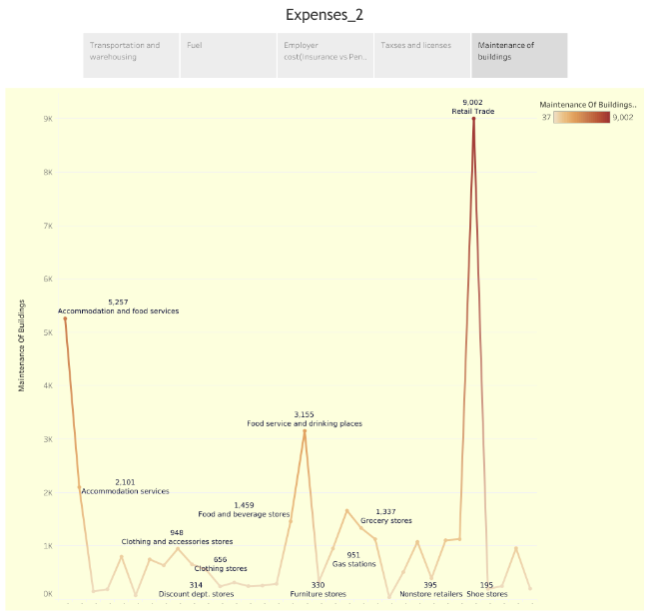

<https://public.tableau.com/app/profile/p.rithikasri/viz/STORY-2_16969253780140/Story2?publish=yes>

**4. ADVANTAGES & DISADVANTAGES**

**ADVANTAGES:**

* Maintenance of business records.
* Preparation of financial statements.
* Comparison of results.
* Decision making.
* Evidence in legal matters**.**

**DISADVANTAGES:**

* Expresses accounting information in terms of money.
* Accounting information is based on estimates.
* Accounting information may be biased.
* Recording of fixed assets at the original cost.
* Money as a measurement unit changes in value.

**5. Application**

* According to the Internal Revenue Service (IRS), business expenses are ordinary and necessary costs incurred to operate your business.
* Fixed expenses are regular and don’t change much — things like rent and insurance.
* Variable expenses are expected, but they can change.

**6. Conclusion**

* The business conclusion should be professional and positive.
* You want to show your optimism and enthusiasm for the company’s success and leave the reader felling interested in or excited about supporting the organization.
* Use strong, active language that shows your confidence in the company.

**7. Future scope**

* Business always has scope in future, only if one is serious about it and aim to prosper and not thrive.
* People often falter in business, because they deem it to be an easy task and look for success very early on.
* Just like a job, business too needs a lot of tie investment and huge amount of pressure to get accustomed.

**8. Appendix**

**SOURCE LINK**

PUBLISHED LINK

**Dataset link:**

https://drive.google.com/drive/folders/1CCxjo561-uTwp260h-YbAj9jurbEcXcB?usp=drive_link

**DASHBOARD 1:**

<https://public.tableau.com/app/profile/p.rithikasri/viz/Dashboard-1_16964099733850/Dashboard1?publish=yes>

**Dashboard 2:**

<https://public.tableau.com/app/profile/p.rithikasri/viz/Dashboard-2_16964103819570/Dashboard2?publish=yes>

**Dashboard 3:**

<https://public.tableau.com/views/Dashboard-3_16964107948900/Dashboard3?:language=en-US&publish=yes&:display_count=n&:origin=viz_share_link>

**Story 1:**

<https://public.tableau.com/app/profile/p.rithikasri/viz/STORY-1_16969242550530/Story1?publish=yes>

**Story 2:**

<https://public.tableau.com/app/profile/p.rithikasri/viz/STORY-2_16969253780140/Story2?publish=yes>